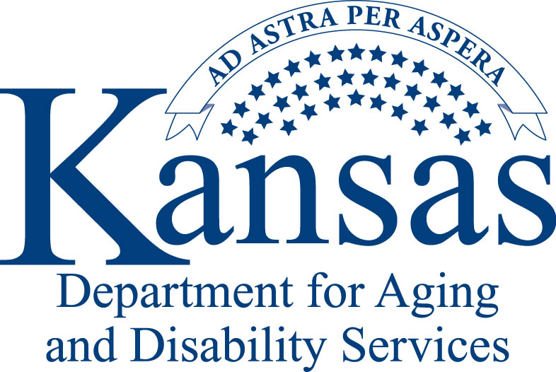
APPLICATION FOR INDIVIDUAL RE-CERTIFICATION

Please open the form and fill in the grey boxes by typing in Microsoft Word and email to the address provided. Handwritten applications will not be processed.

Please check if you re-certifying for a:
KS Certified Gambling Counselor Level -I KCGC Level- II

My current certification expires on: Date of Birth:

Education Level:

Legal Name:

Home Address: City: State: Zip: Home Telephone:

Office/Work Address: City: County: State: Zip:

Office/Work Telephone: Fax:

Name of program you work for if applicable:

Mailed Communication Information
If certificate should go to a different location other than the home address, designate the mailing address.
Address:
City:
State: Zip:

Electronic Communication
Please provide an email address to receive emails from the State.

Email:

Individual services are available in the following languages:
Please check all those that apply for the Individual listed above.

Spanish
Korean
Vietnamese
American Sign Language (ASL)
Other: (Please specify)

Checklist for Application

(For Problem Gambling - Kansas Certified Gambling Counselor Level One and Two)

Application Form
Signed copy of Gambling Specific Continuing Education Hours
Copies of gambling specific CEU certificates
Signed Professional Code & Ethical Agreement
Signed Merit of Public Trust
A copy of Licenses and/or Credentials (if any licenses or credentials have changed since your last certification period)
Confirmation email from KDADS of clinical supervision hours with Dr. Lori Rugle

Please return the completed application with all required materials to:
Carol.Spiker@ks.gov
Or
KDADS
SUD Behavioral Health Services / Attention: Carol Spiker
503 S. Kansas Avenue
Topeka, KS 66603-3404
Gambling Specific Continuing Education Hours

Name of Applicant

To renew your KCGC certification, please document below the required 12 gambling specific hours of continued education during the previous two (2) year cycle.

- If you attended a training/workshop, please list below the training/workshops that you attended and attach all copies of your certificates of attendance (certificate of training, date and number of hours).

- If you presented at a gambling workshop or training, you may count up to a maximum of 6 hours (of your total 12 required hours). Please list below the training/workshops and attach copies of verification of presentation (agenda, your name as presenter and hours of your presentation.)

Training Date | Training Title | Trainer Name | # of Gambling Specific CEUs
 |  | TOTAL HOURS EARNED: | 0.00

AFFIRMATION:
I certify that I voluntarily make this re-certification application, and freely submit myself to the evaluation of KDADS/BHS. I will accept the decision of KDADS/BHS and do accept full responsibility for any and all consequences of the process of seeking re-certification. To the best of my knowledge, the information contained in this re-certification application is true and correct. I authorize members or representatives of KDADS/BHS to contact and obtain information from any trainers or agencies who conducted the trainings deemed necessary in evaluation of this re-certification. I have read the KCGC Professional Code and Ethical Agreement and understand its meaning. I further understand that any violation of this code and agreement may result in suspension or revocation of my certificate. I further understand that revocation of any of my BSRB state licenses may result in suspension or revocation of my certificate. I understand I must notify KDADS/BHS of any address or name change within 30 days of occurrence.

Signature of Applicant for Re-Certification Date
Professional Code and Ethical Agreement
Kansas Certified Gambling Counselor (KCGC)

To be read and signed by the applicant
Please type

Applicant:
- I shall support all efforts toward a primary goal of recovery for clients and families.
- I shall conform to all rules and regulations pertaining to the confidentiality of all records, materials and communications concerning clients.
- I shall demonstrate respect for clients by maintaining an objective, non-possessive professional relationship at all times.
- I shall not discriminate among clients or professionals on the basis of race, color, creed, age, sex or sexual orientation.
- I shall respect the rights and view of other gambling counselors and professionals.
- I shall respect institutional policies and will cooperate with management functions.
- I maintain a genuine interest in helping persons with gambling problems and will help those affected to help themselves.
- I shall assess my own personal and vocational strengths, limitations, and biases. I will recognize when it is in the clients best interest to refer or release him/her to another counselor or program.
- I shall take responsibility for continued professional growth through further education or training.
- I commit to providing the highest quality of care through both personal effort and utilization of any other health professionals or services which may assist the client in his/her recovery plan.
- I do not use alcohol, drugs nor gamble in a manner that will reflect adversely on the credibility and integrity of the profession.

Date Signature of Applicant

Merit of Public Trust

Please answer the following questions. Note: If the answer to any of the items 1 through 11 in this section is "Yes", submit as part of your application a signed, dated type-written explanation that gives specific details including disposition of the matter. A “yes” answer will not automatically exclude you from certification.
- Have you ever been charged with or convicted of a felony or misdemeanor (including Driving Under the Influence convictions) other than a traffic violation? Yes No
- Have you ever had a complaint filed with a professional association or a counselor certifying, licensing, or registering body against you for alleged unethical behavior or unprofessional conduct?
Yes No
- Have you used any alcohol, narcotic, barbiturate, other drug affecting the central nervous system, or other drug which may cause physical or psychological dependence, either to which you were addicted or upon which you were dependent within the last 2 years? Yes No
- Have you been diagnosed or treated for any physical, emotional or mental illness or disease, including alcohol/drug addiction or dependency, which limited your ability to practice behavioral sciences with reasonable skill and safety within the past 2 years? Yes No
- Have you gambled in a manner which would reflect adversely on the credibility and integrity of the profession in the past 2 years? Yes No
- Have you used controlled substances which were obtained illegally or which were not obtained pursuant to a valid prescription order or which were not taken following the direction of a licensed health care provider within the past 2 years? Yes No
- Have you ever had disciplinary action taken against you for unethical behavior, unprofessional conduct or any other grounds? Yes No
- Has any state, jurisdiction, providence, or professional organization denied your application for credentials or professional membership? Yes No
- Have you ever been sued for malpractice, or agreed to pay a settlement in a malpractice suit?
Yes No
- Has any governmental agency ever substantiated allegations made against you for physical, mental or emotional abuse or neglect, sexual abuse, or exploitation of (1) a child, (2) a resident of an adult care home, medical care facility, psychiatric hospital or state institution for the mentally retarded, or (3) an adult? Yes No
- Have you ever been found guilty of or liable for fraud, deceit in connection with services rendered as a behavioral health provider by a civil or criminal court of law or board of a professional organization? Yes No

I certify that I voluntarily make this application, and freely submit myself to the evaluation of KDADS/BHS. I will accept the decision of KDADS/BHS and do accept full responsibility for any and all consequences of the process of seeking certification. To the best of my knowledge, the information contained on this application is true and correct. I authorize members or representatives of KDADS/BHS to contact and obtain information or opinions from any references, employers or educational institutions or agencies deemed necessary in evaluation of this application for certification. I have read the KCGC Code of Ethics and understand its meaning. I further understand that any violation of the Code of Ethics may result in suspension or revocation of my certificate. I further understand that revocation of my state credential or license may result in suspension or revocation of my certificate. I understand I must notify KDADS/BHS of any address or name change within 30 days of occurrence.

Date Signature of Applicant

Scope of Practice for Kansas Certified Gambling Counselors

The following list describes the tasks for which the gambling counselor is certified:
- Intake
- With the appropriate clinical licensure or clinical oversight, diagnosing Pathological Gambling through assessment and evaluation
- Treatment planning
- Facilitating logistics of treatment for individuals, family, significant others and group counseling
- Perform continuous client evaluation
- Referrals
- Crisis Intervention
- Case management
- Client follow-up contact
- Seek and use collateral support (employer, friends, etc.)
- Record keeping and reports
- Coordination of treatment plan
- Outreach, education, training and prevention
- Case consultation
- Evaluation of treatment outcomes, identification of treatment gaps and overlaps
- Program development, evaluation and consultation
- Identification and coordination of community resources

Does not include formal interventions facilitated by a trained Kansas Interventionist for Problem Gambling (KIPG).

