Employment First
Jan. 26, 2023
- Introduction of Agenda
- NEON
- RFP
- Recurring E1st Stakeholder Meetings- 4th Thursday – dates outlined
- Kansas Targeted Employment Act
- Introductions in Chat
- Email with other questions to Christina
- Review of FMAP Team Slide
- NEON – National Expansion of Opportunities Network
- 10 states awarded and Kansas is one of them - we will get 100 hours of Technical Assistance
- SMEs experience in implementation
- Kansas would like to rate restructure
- Kansas gets to chose the SMEs
- Rachel Neuman- Kansas Targeted Employment Act
- Will go back to 2022-2027 – anyone can apply for this tax rebate
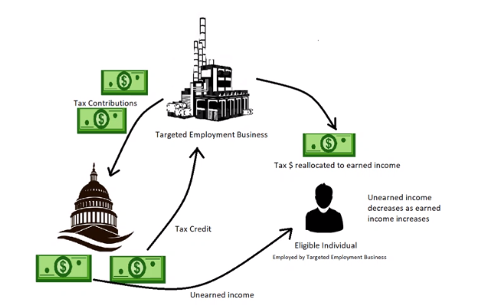
- Business has to be “for profit,” have to complete integrated employment, have to employee IDD
- Individual just has to have earned income- no min or max
- Link to form K-69 - https://www.ksrevenue.gov/pdf/k-69.pdf
- We want it to expand to all disabilities
- Employers notified by word of mouth; KDADs is working on presentation
- Q&A
- Are there written materials? Nick from Interhab- that was our plan today was to put the information out there. Brochure less intimidating than a tax form
- Sounds like Targeted Job Tax Credit and it was helpful to have a form
- Disability Mentoring Day in October
- Employer can’t ask for credit above prevailing wage and employer has to pay the minimum wage. Who determines that wage? Want employers to pay the same as they would anyone else in that type of position.
- Minimum wage may go up to $15 hr- if minimum wage goes up, we will have to go to legislatures.
- Communication
- Slides and notes w/chat information will be provided
- Mandy mentioned – Lisa Mills, meeting w/her next week
- Will be sure to post and email stakeholders once RFP posted
- KCDD offered technical assistance – NEON contract will last until Aug. and we could use support then
- How are we collaborating with VR? Pulling in STEPS, pulling in SMEs and all parties interested.
- Cheryl Lakker would like to work with folks interested to discuss individuals being forced in retiring at 65 y/o under WORK
- SW KS Employment Conf. in April in Wichita

Chat :

[1:32 PM] Anderson, Angeline, JCD
Angeline Anderson, Johnson County Developmental Supports
​[1:32 PM] Nick Wood (Guest)
Nick Wood, InterHab
​[1:32 PM] Cheryl L. Laaker (Guest)
Cheryl Laaker - Sunflower Health Plan, Mgr of Community Engagement/SDOH
​[1:32 PM] May, Shelly, JCD
Shelly May, Johnson County Developmental Supports
​[1:32 PM] Curry-King, Latoya, JCD (Guest)
Latoya Curry-King, Employment Team Leader, JCDS
​[1:32 PM] Susan Segelquist [KDADS]
Susan Segelquist, KDADS BI Program Manager
​[1:32 PM] Sherri Marney [KDHE]
Sherri Marney, KDHE WORK Program Manager. WORK is part of Working Healthy.
​[1:33 PM] Hall, Jean P
Jean Hall, KU Research & Training Center on Independent Living
​[1:33 PM] Zac Wilson [KDADS]
Zac Wilson KDADS Behavioral Health Commission Assertive Community Treatment Specialist
​[1:33 PM] Parent-Johnson, Wendy - (wparentjohnson)
Wendy Parent-Johnson, Sonoran Center for Excellence in Disabilities, Arizon. So good to see all of you again!
[1:33 PM] Jamie Katsbulas [KDADS]
Department of Labor selects 10 states, District of Columbia for national effort to expand employment opportunities, outcomes for people with disabilities | U.S. Department of Labor (dol.gov)
Edited​[1:33 PM] Colin Olenick (Guest)
Colin Olenick Self Advocacy Coalition of Kansas
​[1:33 PM] Bruce, Vincent, JCD (Guest)
Vincent Bruce, Employment Team Leader JCDS
​[1:33 PM] Seth Kilber [KDADS]
Seth Kilber, KDADS
[1:34 PM] Angie Saenger (Guest)
Angie Saenger, Independent Connection. The Center for Independent Living, based in Salina.
​[1:35 PM] Tami Allen
Tami Allen, Families Together Inc
​[1:36 PM] Joe Sarlett, APSE Public Policy Liaison-KS (Guest)
Joe Scarlett, APSE Public Policy Liaison-KS, KS Employment First Oversight Commission Appointment Pending)
​[1:36 PM] Ski Adams (Guest)
ski adams. Self-advocate from Kansas City Kansas.
[1:42 PM] Noelle Kurth (she, her) (Guest)
Why is this only employees with I/DD and not any type of disability?
[1:48 PM] Amanda Myers (Guest)
I went to the website but it just shows one page for the K-9. Do you know where the other forms are located?
​[1:48 PM] Nick Wood (Guest)
https://www.ksrevenue.gov/pdf/k-69.pdf
(2 liked)​[1:49 PM] Amanda Myers (Guest)
thank you!
​[1:49 PM] Noelle Kurth (she, her) (Guest)
My question was answered in the presentation
​[1:49 PM] Tami Allen
How are employers being notified of this tax incentive.
[1:53 PM] Hall, Jean P
Speaking of the WOTC, does this program work in concert with the federal tax credit?
[1:55 PM] Noelle Kurth (she, her) (Guest)
I think direct outreach to employers is needed too. Making consumers aware is always good, but putting it back on the people seeking work themselves to inform employers is burdensome.
(2 liked)​[1:57 PM] Knutson, Craig [KCDD]
Will this slide deck be available after today's meeting?
[1:58 PM] Nick Wood (Guest)
https://www.dol.gov/agencies/eta/wotc
​[2:01 PM] Sara Hart Weir (Guest)
Thank you for your hard work!
​[2:02 PM] Mandy Flower [KDADS]
Thank you, Rachel
​[2:02 PM] Rachel Neumann
Thank you (smile)
​[2:03 PM] Noelle Kurth (she, her) (Guest)
You mentioned a link in the chat about NEON, I don't see it, can you provide it again? thank you!
​[2:03 PM] Jamie Katsbulas [KDADS]
Department of Labor selects 10 states, District of Columbia for national effort to expand employment opportunities, outcomes for people with disabilities | U.S. Department of Labor (dol.gov)
​[2:03 PM] Knutson, Craig [KCDD]
Lisa Mills is awesome
​[2:03 PM] Noelle Kurth (she, her) (Guest)
nevermind. I see it now.
(1 liked)​[2:04 PM] Noelle Kurth (she, her) (Guest)
Thanks Jamie.
(1 liked)​[2:04 PM] Cheryl L. Laaker (Guest)
It would be great if we can look at increasing the age that someone has to age out of Working Healthy from 65!
(1 liked)
[2:06 PM] Knutson, Craig [KCDD]
Great question, SKi
​[2:08 PM] Sherri Marney [KDHE]
I completely agree.
​[2:08 PM] Sherri Marney [KDHE]
I am the WORK Program Manager. My email is sherri.marney@ks.gov .
​[2:08 PM] Hall, Jean P
Yes, the 65 cap for WH needs to be removed.
​[2:09 PM] Erin Sanders Hahs [KDHE]
I am the STEPS Program Manager (also under Working Healthy). My email is erin.sandershahs@ks.gov
​[2:09 PM] Sherri Marney [KDHE]
I would love to see the 65 age cap removed. This really does impact members more and more with people needing to be over 65 to reach full benefit.
(1 liked)​[2:10 PM] Nick Wood (Guest)
Thank you everyone
​[2:10 PM] Sherri Marney [KDHE]
Thank you

