Annual Report | 2017 -18

GOVERNOR’S BEHAVIORAL HEALTH SERVICES PLANNING COUNCIL
CHILDREN’S SUBCOMMITTEE

PRESENTED TO:
Wes Cole, Chair
Governor’s Behavioral Health Services Planning Council
Tim Keck, Secretary
Kansas Department for Aging and Disability Services
Jeff Colyer, Governor
State of Kansas

CONTENTS:
Introduction
Summary of Recommendations
2017 - 18 Goals and Accomplishments
2018 - 19 Goals
References
Appendices:
- Children’s Subcommittee Charter
- Subcommittee Members

INTRODUCTION:
You only need to listen to or read the news to be aware of the immediate need for attention to children’ mental health issues. The recent school shootings and the rise in adolescent suicide alone are indicators that we are at a critical juncture in making sure that mental health prevention and intervention are one of our highest priorities. According to the Center for Disease Control, 1 in 5 high school students report being bullied on school property in the last year. Youth violence is the leading cause of death for young people and results in more than 500,000 nonfatal injuries each year. (1) For instance, the homicide rate among adolescents and young adults is higher than any other age group. Young people can be harmed by violence when they are the perpetrator, the victim, or a witness. Some forms of youth violence—such as bullying, slapping, or hitting—can cause more emotional harm than physical harm. Others, such as robbery and assault (with or without weapons), can lead to serious injury or even death. (2)
Exposure to this kind of violence not only causes physical damage, it also erodes the mental and social lives of its victims. Suicide is the second leading cause of death in adolescents aged 12 to 17, according to the Center for Disease Control. It is estimated that 6.8% of the total population of children aged 3 to 17 are diagnosed with ADHD, 3.5% with behavioral or conduct problems, 3% with anxiety, and 2.1% with depression. (3) In a study conducted by Cambridge University, those children who experience multiple Adverse Childhood Experiences (ACES) were more likely to develop a lifetime of mental and substance use disorders in adulthood, as well as physical health issues. (4) In Kansas, parents report that 23% of children 2 to 17 years of age have been diagnosed by their doctor as having Autism, developmental delays, depression and/or anxiety, Attention Deficit Hyperactivity Disorder (ADHD), or behavioral/conduct disorders. (5) The mental health rate per 1,000 children aged 0 to 17, who are identified as discharging from a hospital with a mental health diagnosis, has increased from 2.8 in 2011 to 5.1 in 2016.(6)

It is essential that all stakeholders look for solutions to address these statistics and enhance behavioral health services for the children and youth of Kansas and their families.

SUMMARY OF RECOMMENDATIONS:
Below each of the four goals outlined below is a summary of the recommendations from the Children’s Subcommittee. More detail for each of these recommendations can be found in the body of this report.

Goal #1: Identify a Process for the Children’s Subcommittee to Link/Communicate Well with Other Subcommittees
- Continue joint meetings convened by KDADS with all subcommittees quarterly or at least once every six months. This will help with networking, if subcommittees are working on the same issues or issues that overlap each other. The Children’s Subcommittee anticipates an invitation or request from KDADS or the Council to participate in future joint meetings.
- Instead of a newsletter, which was previously tried, the main council will designate a person to lead and organize all subcommittees and post minutes of their meetings to a central location on a shared drive for all other subcommittees to review. This lead person would coordinate with each subcommittee’s designated person to have the minutes posted and hold each subcommittee’s officers accountable.

Goal #2: Make Recommendations Regarding Caregiver, Parent, and Family Engagement in Navigating Behavioral Health Systems
- State agencies will identify and remove barriers (i.e. policies, procedures, provider requirements) that hinder caregiver, parent, and family engagement.
- State agencies will invest resources (funding) to support, encourage, and increase the direct training and support of parents in the care of their children.
- State agencies will consistently and continually present and share information received from stakeholders in a clear and concise manner with families and providers.
- State agencies will support, encourage, and incentivize programs and agencies that engage families effectively in the planning, governance, evaluation, and provision of behavioral health services.

Goal #3: Define/describe the Kansas Children’s Continuum of Care
The Children’s Subcommittee will continue to work closely with the COC committee to advance the development of solutions to address identified children’s behavioral health issues.

Goal #4: Identify and Describe the Data Elements that the Children’s Subcommittee wants in an Integrated Data System.
- KDADS will appoint an all-inclusive task force to develop the purpose of a statewide EMR/Behavioral Health database and a plan for its development.
- The state will contract with an outside provider to develop this database. The Children’s Subcommittee would recommend considering Dr. Teri Garstka at the University of Kansas to facilitate this process. Dr. Garstka provided a very interesting presentation to the Subcommittee, and its members liked the process utilized to guide agencies through determining the purpose of the database prior to its development.
- Explore the possible replication of the MyRC data base model utilized by Johnson County Mental Health for statewide use in other counties/communities.
- Replicate the already existing IRIS system, as a starting point, and then expand its use statewide. The IRIS system currently tracks a referral between programs for recipients of early childhood services and other program services that are a part of that system.
- KDADS will complete a survey of state agencies and relevant stakeholders including KDOC, KSDE, DCF, KDHE and others, to determine what data elements are already being collected in their current systems and what information is needed by each agency.

2017-2018 GOALS AND ACCOMPLISHMENTS
The Governor’s Subcommittee for Children’s Behavioral Health has addressed the following four goals and accomplishments during the 2017 – 2018 year:

Goal #1 – Identify a Process for the Children’s Subcommittee to Link/Communicate Well with Other Subcommittees
(1) Over the past year, individual Children’s Subcommittee members reviewed previous reports from one of the other subcommittees, to identify areas of possible overlap, and presented a summary of the information to the other Children’s Subcommittee members. The Subcommittee identified the following subcommittees may potentially have a connection or overlap with the work of the Children’s Subcommittee:
- Veteran’s Subcommittee will be doing some work over the next year, once they start meeting again, to look at services for veterans with children, especially supporting veterans upon returning home from service.
- Housing and Homeless Subcommittee probably has data and information related to children and families
- Justice Involved Youth and Adult Subcommittee
- Rural and Frontier Subcommittee
- Prevention (includes suicide prevention) Subcommittee
- Ks Citizen’s Committee on Alcohol and Drug Abuse Subcommittee
- Vocational Subcommittee’s work, as it relates to transitional age youth

(2) Jane Adams, Bobby Eklofe, and Erick Vaughn attended a joint meeting of all subcommittees, convened by KDADS. There was an agreement, at this meeting, that a future meeting would be organized. The Children’s Subcommittee anticipates an invitation or request from KDADS or the Council to participate in future joint meetings.

(3) One month, the Children’s Subcommittee contributed information to the subcommittee newsletter. However, the Children’s Subcommittee did not see the result of that effort and has concerns whether the newsletter was or will be developed or shared.

(4) Erick Vaughn participated in a Prevention Subcommittee meeting and presented the Children’s Subcommittee’s recommendations and goals for this year. Erick provided some additional information to group members, because of questions and comments during the presentation.

Goal #1 Recommendations:
- Continue joint meetings convened by KDADS with all subcommittees quarterly or at least once every six months. This will help with networking, if subcommittees are working on the same issues or issues that overlap each other. The Children’s Subcommittee anticipates an invitation or request from KDADS or the Council to participate in future joint meetings.
- Instead of a newsletter, which was previously tried, the main council will designate a person to lead and organize all subcommittees and post minutes of their meetings to a central location on a shared drive for all other subcommittees to review. This lead person would coordinate with each subcommittee’s designated person to have the minutes posted and hold each subcommittee’s officers accountable.

Goal #2 – Make Recommendations Regarding Caregiver, Parent, and Family Engagement in Navigating Behavioral Health Systems
To learn more about the various perspectives of family engagement, during one of the Children’s Subcommittee meetings, a panel presentation by representatives of agencies that work with parents was hosted, to hear their perspectives and concerns. Agencies represented were CASA, Families Together, and Johnson County Substance Abuse, and an Early Childhood Education representative also participated. The specific request was for each of the representatives to present feedback from parents regarding engagement in services and navigating behavioral health system(s). Below is a list summarizing the concerns that were shared:

Emotional Barriers
      - Stigma
      - Trust
      - Fear of being blamed
      - Feel “I should be able to handle this”
      - Relationship with therapist
      - Culture
Lack of resources
      - Uninsured/Finances for payment of services
      - Lack of early childhood education providers
      - Transportation
      - Limited number of foster homes for children/youth with challenging behaviors or special needs
      - PRTF waiting lists
System Barriers
      - Need wraparound and parent support for non-waiver eligible youth
      - Parent education
      - Train parents as advocates
      - Lack of parent’s participation in therapy if child is incarcerated or placed elsewhere
      - Scheduling
      - No one-stop for physical and behavioral health services and substance use treatment
As indicated by the list above, there are many factors that create challenges and barriers for families to engage in the behavioral health system and for providers to fully engage families and communities in all aspects of the behavioral health system.

Goal #2 Recommendations:
- State agencies will identify and remove barriers (i.e. policies, procedures, provider requirements) that hinder caregiver, parent, and family engagement.
- State agencies will invest resources (funding) to support, encourage, and increase the direct training and support of parents in the care of their children.
- State agencies will consistently and continually present and share information received from stakeholders in a clear and concise manner with families and providers.
- State agencies will support, encourage, and incentivize programs and agencies that engage families effectively in the planning, governance, evaluation, and provision of behavioral health services.

Goal #3 – Define/describe the Kansas Children’s Continuum of Care
The Children’s Subcommittee spent a great deal of time reviewing the charter for the Children’s Continuum of Care Committee (COC) and discussing its purpose and role versus the role of the Children’s Subcommittee. The Children’s Subcommittee also had discussions with members of the COC Committee, as well as members of the Governor’s Planning Council. The Children’s Subcommittee concluded that there is some overlap between the two committees and the topics for which they are responsible. The Children’s Subcommittee eventually came up with a working description that helped clarify the differences. The Children’s Subcommittee’s working definition is that the Children’s Subcommittee has the task of identifying relevant topics of concern and offering suggestions for change. It is the task of the Children’s Continuum of Care Committee to then take these identified issues and recommendations and move them forward with the Secretary and the Legislature.
Goal #3 Recommendation: The Children’s Subcommittee will continue to work closely with the COC committee to advance the development of solutions to address identified children’s mental health issues.

Goal #4 – Identify and Describe the Data Elements that the Children’s Subcommittee wants in an Integrated Data System.
The Children’s Subcommittee members believe that having a statewide database would be very valuable for several purposes:
- Identifying the issues that are the most urgent in the state,
- Monitoring the progress the Children’s Subcommittee and others are making, and
- Sharing information to better serve children and families.
The first thing the Children’s Subcommittee did was explore and inform its members about existing databases in the state. The Children’s Subcommittee reviewed the information available from the MCOs, Medicaid AIMS data, KSDE and other available systems. Johnson County Mental Health Adolescent Center for Treatment (ACT) is involved in a particularly interesting model called My RC (My Resource Connection). This system connects individuals who access it with many resources they might need, including housing, health care, counseling, transportation, etc., by providing contact information on a public website.
The Children’s Subcommittee invited Teri A. Garstka, Ph.D, Associate Director for the Center for Public Partnerships and Research at the University of Kansas, to talk to its members about the DAISEY and IRIS systems that are already being utilized in some areas of the state Dr. Garstka presented a model for determining what an organization wants to get from a database that the Children’s Subcommittee thought was very helpful.
We would also recommend the State look at the model created and utilized by Johnson County Mental Health called MyRC. They have already worked out many of the issues of HIPPA and information sharing that might be very helpful for the process.
Goal #4 Recommendations:
- KDADS will appoint an all-inclusive task force to develop the purpose of a statewide EMR/Behavioral Health database and a plan for its development.
- The state will contract with an outside provider to develop this database. The Children’s Subcommittee would recommend considering Teri Garstka, Ph.D. at the University of Kansas to facilitate this process. Dr. Garstka provided a very interesting presentation to the Subcommittee, and its members liked the process utilized to guide agencies through determining the purpose of the database prior to its development.
- Explore the possible replication of the MyRC data base model utilized by Johnson County Mental Health for statewide use in other counties/communities.
- Replicate the already existing IRIS system, as a starting point, and then expand its use statewide. The IRIS system currently tracks a referral between programs for recipients of early childhood services and other program services that are a part of that system.
- KDADS will complete a survey of state agencies and relevant stakeholders including KDOC, KSDE, DCF, KDHE and others, to determine what data elements are already being collected in their current systems and what information is needed by each agency.

2018-19 Goals
At the end of each year, the Children’s Subcommittee considers a large list of possible concerns and topics to prioritize goals for the following year. This year those topics included: Autism, Early Childhood Education/Services, Homelessness, Human Trafficking, Opioid and other related drug issues impacting children, Parent Engagement, Transition age youth aging out, and Trauma Informed Care. The Children’s Subcommittee prioritized these issues. However, the Children’s Subcommittee members felt it was frustrating to have questions regarding issues due to a lack of data and information to assist in prioritizing these topics and concerns.
Using the experience and knowledge of those serving on the Children’s Subcommittee, the following goals were identified to pursue during the 2018-2019 year. The Children’s Subcommittee acknowledges that, in pursuing these goals, a focus on resources for substance use services and treatment for parents must be maintained, as this has been missing from the Children’s Subcommittee’s previous work.
Goals:
- Research resources available for parents with substance use disorders, specifically drug use that is affecting the care of their children. Consider making recommendations regarding how these resources can be increased in communities lacking resources, to improve outcomes for children.
- Review existing recommendations regarding Transition Age Youth and prioritize those recommendations. Prioritize recommendations that focus on services after youth leave State of Kansas - DCF custody, including access to housing, employment and education.
- Review and recommend Parent Engagement models across the continuum of care (schools, CMHCs, early childhood programs, etc.). The Children’s Subcommittee’s review will include parenting training of parents and training of direct service staff.

References:
- Kann L. McManus T., Harris WA, et. al. Youth Risk Behavior Surveillance – United States, 2015. MMWR Morb Mortal Surviel Summ. 2016; 65 (SS-06); 1-174. Available from http://www.cdc.gov/mmwr/volumes/65/ss/pdfs/ss6506.pdf.
- http://www.cdc.gov/health communications; “Violence and Homicide Among Youth” September 15, 2017.
- Data & Statistics: Mental, Behavioral and Developmental Health of Children aged 2-17. https://www.cdc.gov/childrensmentalhealth/data.html. 2005-2011.
- Association of adverse childhood experiences with lifetime mental and substance use disorders among men and women aged 50+ years. https://www.cambridge.org/core/journals/international-psychogeriatrics/article. Volume 29, Issue 3. March 2017, pp. 359-372.
- Children who have one or more emotional, behavioral, or developmental conditions; KIDS Count Data Center. https://datacenter.kidscount.org/data/tables9699; December, 2017.
- Mental Health Rates per 100; https://datacenter.kidscount.org/data/tables/1267; 2018.

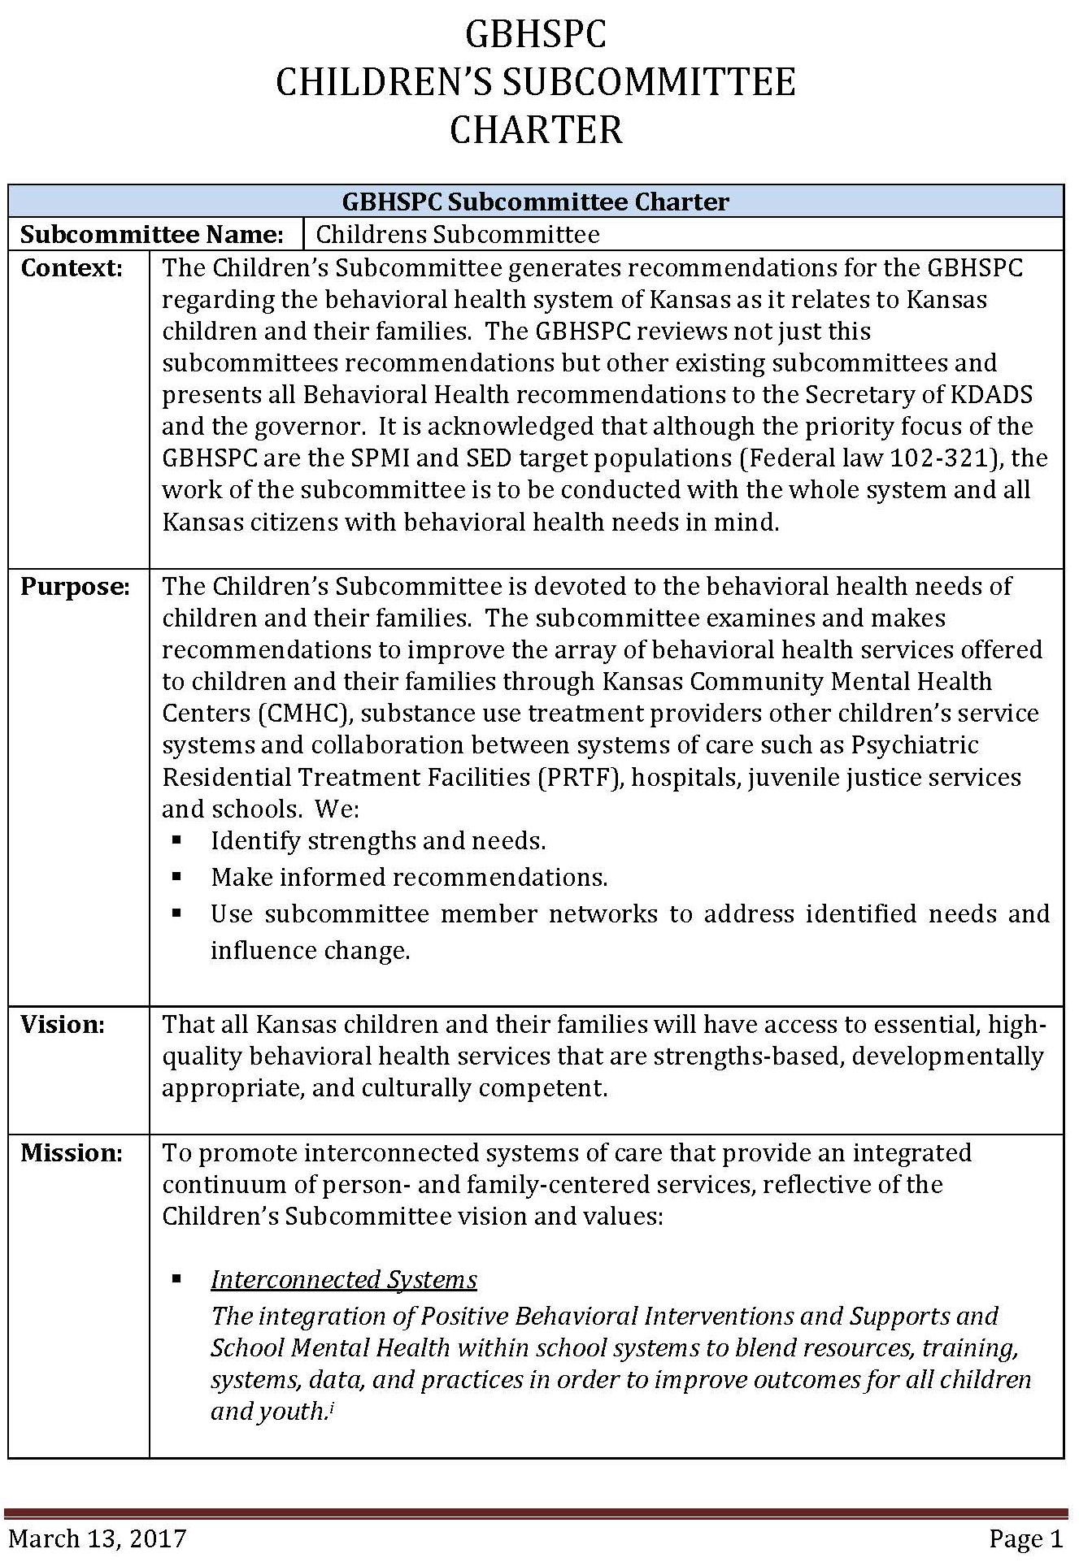
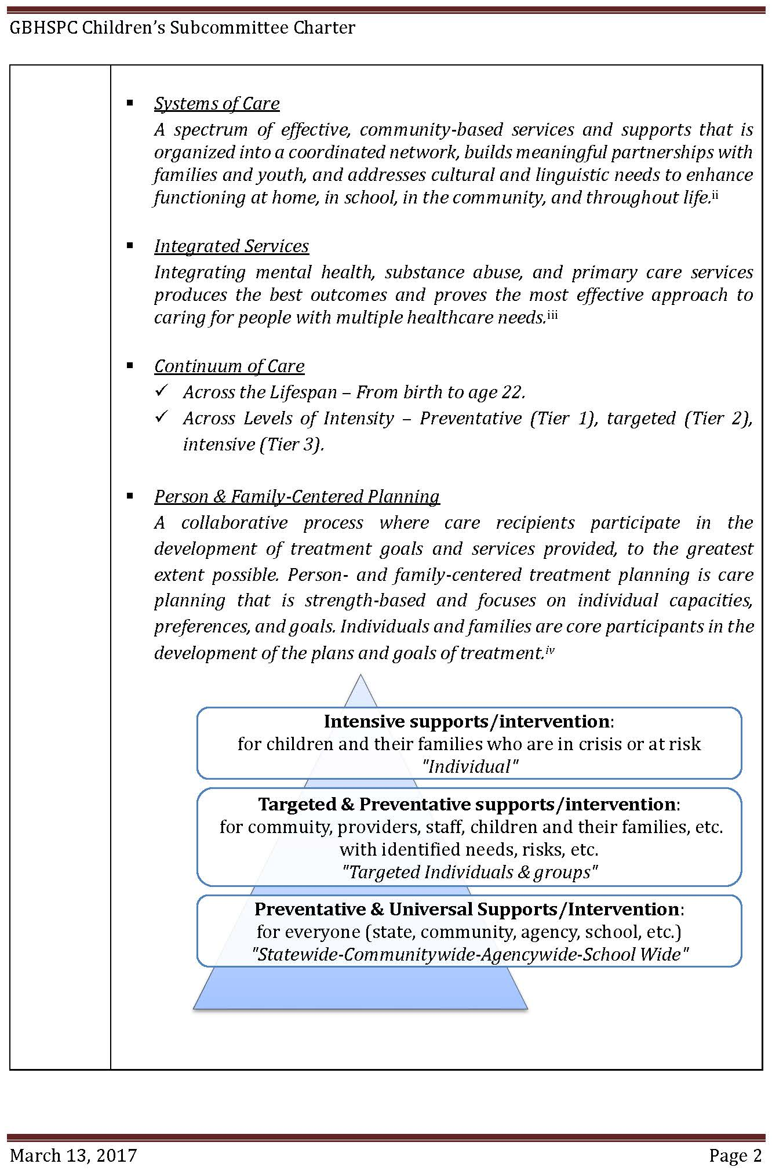
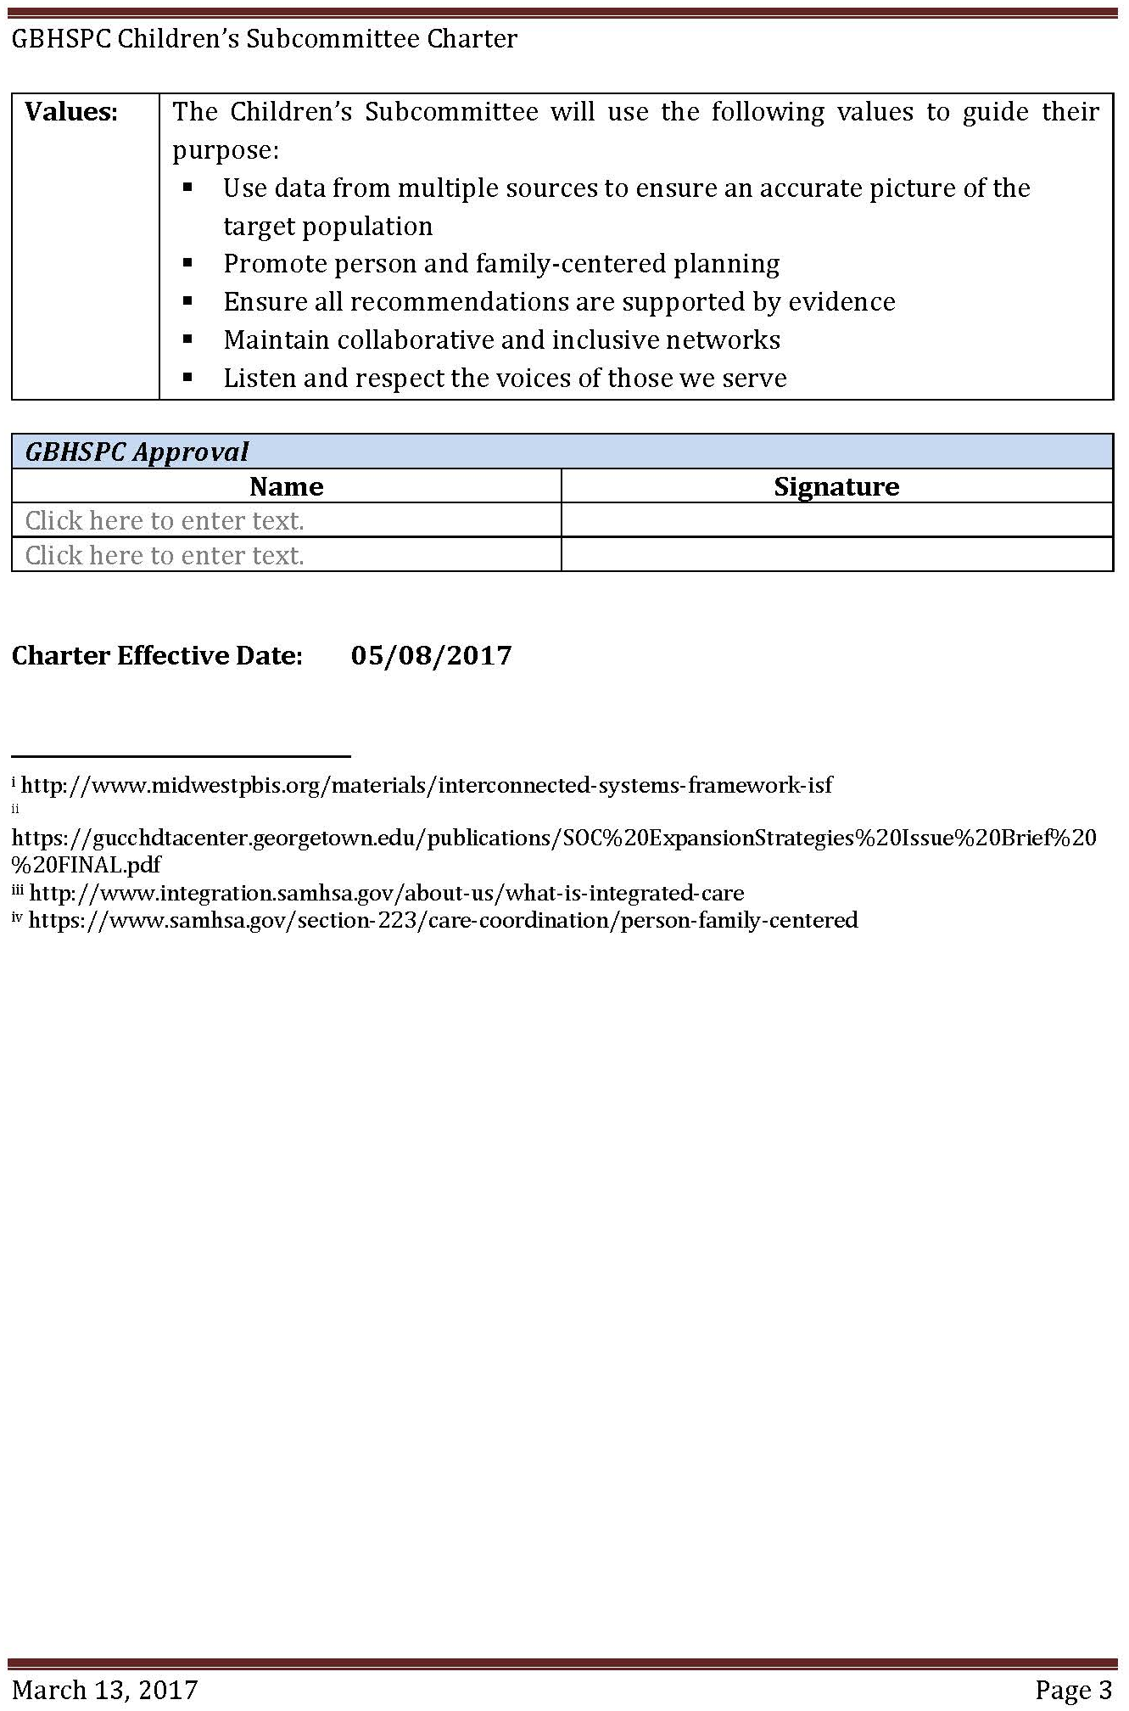
Subcommittee Members

- Nancy Crago, LSCSW, Chair, Director of Psychosocial Rehabilitation, Family Service and Guidance Center
- Erick Vaughn, LMSW, Vice Chair, Director of Strategic Initiatives, DCCCA, Inc.
- Robert (Bobby) Eklofe, MHSA, Secretary, Vice President of Behavioral Health Operations, KVC Hospitals, Inc.
- Cherie Blanchat, LSCSW, Past Chair Project Coordinator, TASN ATBS School Mental Health Initiative
- Candace Moten, LMSW - Family Preservation Services Program Manager, Kansas Department for Children and Families
- Jeff Butrick, Service Manager, Kansas Department of Corrections-Juvenile Services
- Kevin Kufeldt, LCPC, Program Manager, ACT Residential Treatment, Johnson County Mental Health
- Cheryl Rathbun, Chief Clinical Officer, Saint Francis Community Services
- Chelle Kemper, Secretary, Special Education Director
- Jacob Box, Parent Representative, Governor’s Behavioral Health Services Planning Council Liaison
- Gary Henault, KDADS Liaison, Kansas Department for Aging and Disabilities Services, Children’s Program Manager
- Myron Melton, Education Consultant, Special Education and Title Services Team, Kansas
- Charlie Bartlett, KDADS Liaison, Kansas Department for Aging and Disabilities Services, Special Projects
- Julie Ward, LSCSW, Topeka Public Schools, Department of School Social Work
- Marci Ramsay, LSCSW, RPT, Douglas County Child Development Association
- Rich Harrison, Behavior Consultant, Project Stay
- Sherri Luthe, Parent Representative
- Vicki Vossler, Special Education Administrator, Blue Valley Schools

