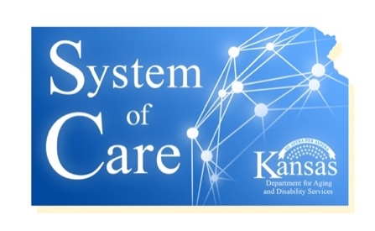
Minutes
Cultural Awareness Committee
September 25, 2019
4:00 PM – 5:00 PM
877-400-9499 // 867-102-1548

- Call to Order

- Attendees: Isiah Lykes, DeLetha Kelley, Debra Garcia

- Feedback on the internal review by the CMHC’s on the first draft of CLC Plan? Implementation issues?

No issues reported. The committee liked the idea of having a succinct marketing piece to be able to share with CBS staff on best practices of cultural competency. The committee proceeded to review the draft of the marketing slick.

- Marketing Slick Ideas

The team reviewed the marketing slick and decided for the most part there were too many words for the size of the document, but all liked the size of the slick and wanted to stay with that size of finished product. The committee went line by line and edited the 10 best practice messages to best maintain the message while improving the readability.

Next CLC Committee Meetings will be: October 9th

